UNITED STATES
SECURITIES AND EXCHANGE COMMISSION
Washington, D.C. 20549
____________________________________________________________
FORM 8-K
____________________________________________________________

CURRENT REPORT

Pursuant to Section 13 or 15(d) of The Securities Exchange Act of 1934

Date of Report (Date of earliest event reported): August 27, 2026

____________________________________________________________
GLACIER BANCORP, INC.
(Exact name of registrant as specified in its charter)
____________________________________________________________
Montana |  |  | 001-41170 |  |  | 81-0519541
(State or other jurisdiction  of incorporation) |  |  | (Commission  File Number) |  |  | (IRS Employer  Identification No.)
49 Commons Loop |  |  | Kalispell, |  |  | Montana |  |  | 59901
(Address of principal executive offices) |  |  |  |  |  |  |  |  | (Zip Code)
(406) |  |  |  |  |  |  |  |  | 756-4200
(Registrant’s telephone number, including area code)
____________________________________________________________

Check the appropriate box below if the Form 8-K filing is intended to simultaneously satisfy the filing obligation of the registrant under any of the following provisions:
☐ Written communications pursuant to Rule 425 under the Securities Act (17 CFR 230.425)
☐ Soliciting material pursuant to Rule 14a-12 under the Exchange Act (17 CFR 240.14a-12)
☐ Pre-commencement communications pursuant to Rule 14d-2(b) under the Exchange Act (17 CFR 240.14d-2(b))
☐ Pre-commencement communications pursuant to Rule 13e-4(c) under the Exchange Act (17 CFR 240.13e-4(c))
Securities registered pursuant to Section 12(b) of the Act:
Title of each class |  |  | Trading Symbol(s) |  |  | Name of each exchange on which registered
Common Stock, $0.01 par value |  |  | GBCI |  |  | The New York Stock Exchange

Indicate by check mark whether the registrant is an emerging growth company as defined in as defined in Rule 405 of the Securities Act of 1933 (§230.405 of this chapter) or Rule 12b-2 of the Securities Exchange Act of 1934 (§240.12b-2 of this chapter).
Emerging growth company ☐

If an emerging growth company, indicate by check mark if the registrant has elected not to use the extended transition period for complying with any new or revised financial accounting standards provided pursuant to Section 13(a) of the Exchange Act. ☐

Item 8.01 Other Events

On August 27, 2026, the Board of Directors (the “Board”) of Glacier Bancorp, Inc. (the “Company”), appointed Byron Pollan to serve as Senior Vice President in the newly created position of Deputy Chief Financial Officer of the Company and Glacier Bank, effective September 1, 2026. Upon Ron Copher’s previously announced retirement, now planned for mid-2027, Mr. Pollan will become an Executive Vice President and Chief Financial Officer of the Company and Glacier Bank, succeeding Mr. Copher. Mr. Copher will remain with the Company in an advisory role for a period of time to support a smooth transition.

Mr. Pollan brings 27 years of experience in banking and financial services. He has served as Senior Vice President and Treasurer of the Company since January 2017. Prior to joining the Company, he served as Treasurer of CIT Bank, where he established the Treasury Department and Chaired the ALCO Committee. Earlier in his career, Mr. Pollan was a portfolio manager at Freddie Mac. He is a 1999 graduate of Brigham Young University, where he earned a Bachelor of Science degree in International Finance, and has been a CFA® charterholder since 2003.

Cautionary Note Regarding Forward-Looking Statements

This current report on Form 8-K contains forward-looking statements within the meaning of the Private Securities Litigation Reform Act of 1995. Forward-looking statements can be identified by words such as “estimate,” “anticipate,” “expect,” “will,” and similar references to future periods. Such forward-looking statements include but are not limited to statements regarding the Company’s expectations concerning continued and future service arrangements with Messrs. Copher and Pollan. Readers are cautioned not to place undue reliance on the forward-looking statements, which speak only as of the date on which they are made and reflect management’s current expectations and beliefs. The Company undertakes no obligation to publicly revise or update the forward-looking statements to reflect events or circumstances that arise after the date of this report. For more information, see the risk factors described in the Company’s Annual Report on Form 10-K, Quarterly Reports on Form 10-Q and other filings with the Securities and Exchange Commission from time to time.

Item 7.01 Regulation FD Disclosure

A copy of the press release announcing Mr. Pollan’s appointment as Senior Vice President and Deputy Chief Financial Offer is furnished as Exhibit 99.1 to this report and incorporated by reference.

Item 9.01 FINANCIAL STATEMENTS AND EXHIBITS

(d) Exhibits

99.1 Press Release dated August 31, 2026
104 Cover Page Interactive Data File (embedded within the Inline XBRL document).

SIGNATURES

Pursuant to the requirements of the Securities Exchange Act of 1934, the registrant has duly caused this report to be signed on its behalf by the undersigned hereunto duly authorized.

Dated: |  |  | August 31, 2026 |  |  | GLACIER BANCORP, INC.
 |  |  |  |  |  | /s/ Randall M. Chesler
 |  |  |  |  |  | By: |  |  | Randall M. Chesler
 |  |  |  |  |  |  |  |  | President and Chief Executive Officer

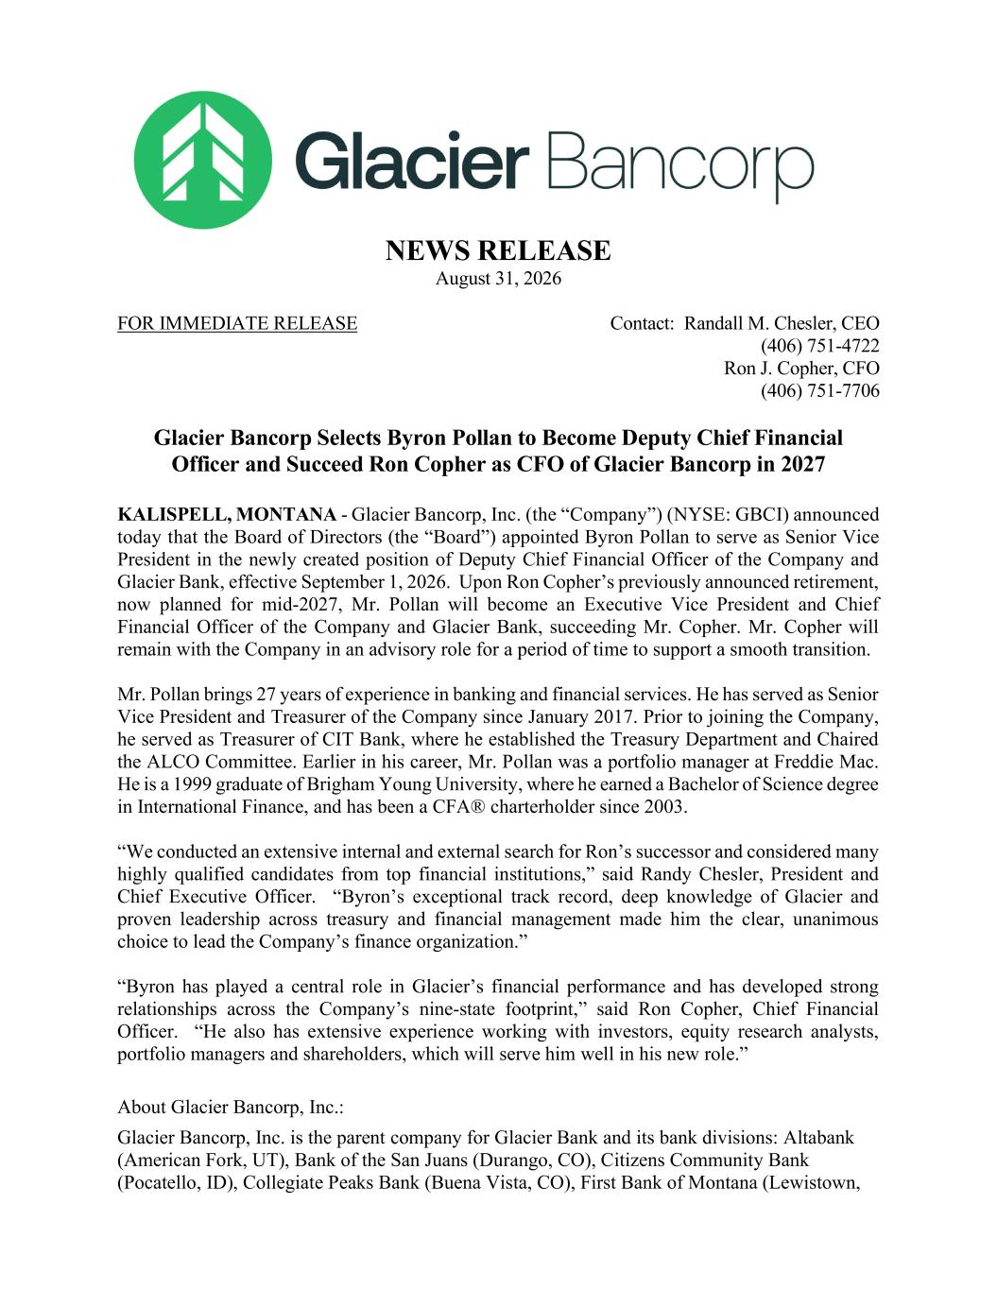

NEWS RELEASE August 31, 2026 FOR IMMEDIATE RELEASE Contact: Randall M. Chesler, CEO (406) 751-4722 Ron J. Copher, CFO (406) 751-7706 Glacier Bancorp Selects Byron Pollan to Become Deputy Chief Financial Officer and Succeed Ron Copher as CFO of Glacier Bancorp in 2027 KALISPELL, MONTANA - Glacier Bancorp, Inc. (the “Company”) (NYSE: GBCI) announced today that the Board of Directors (the “Board”) appointed Byron Pollan to serve as Senior Vice President in the newly created position of Deputy Chief Financial Officer of the Company and Glacier Bank, effective September 1, 2026. Upon Ron Copher’s previously announced retirement, now planned for mid-2027, Mr. Pollan will become an Executive Vice President and Chief Financial Officer of the Company and Glacier Bank, succeeding Mr. Copher. Mr. Copher will remain with the Company in an advisory role for a period of time to support a smooth transition. Mr. Pollan brings 27 years of experience in banking and financial services. He has served as Senior Vice President and Treasurer of the Company since January 2017. Prior to joining the Company, he served as Treasurer of CIT Bank, where he established the Treasury Department and Chaired the ALCO Committee. Earlier in his career, Mr. Pollan was a portfolio manager at Freddie Mac. He is a 1999 graduate of Brigham Young University, where he earned a Bachelor of Science degree in International Finance, and has been a CFA® charterholder since 2003. “We conducted an extensive internal and external search for Ron’s successor and considered many highly qualified candidates from top financial institutions,” said Randy Chesler, President and Chief Executive Officer. “Byron’s exceptional track record, deep knowledge of Glacier and proven leadership across treasury and financial management made him the clear, unanimous choice to lead the Company’s finance organization.” “Byron has played a central role in Glacier’s financial performance and has developed strong relationships across the Company’s nine-state footprint,” said Ron Copher, Chief Financial Officer. “He also has extensive experience working with investors, equity research analysts, portfolio managers and shareholders, which will serve him well in his new role.” About Glacier Bancorp, Inc.: Glacier Bancorp, Inc. is the parent company for Glacier Bank and its bank divisions: Altabank (American Fork, UT), Bank of the San Juans (Durango, CO), Citizens Community Bank (Pocatello, ID), Collegiate Peaks Bank (Buena Vista, CO), First Bank of Montana (Lewistown,

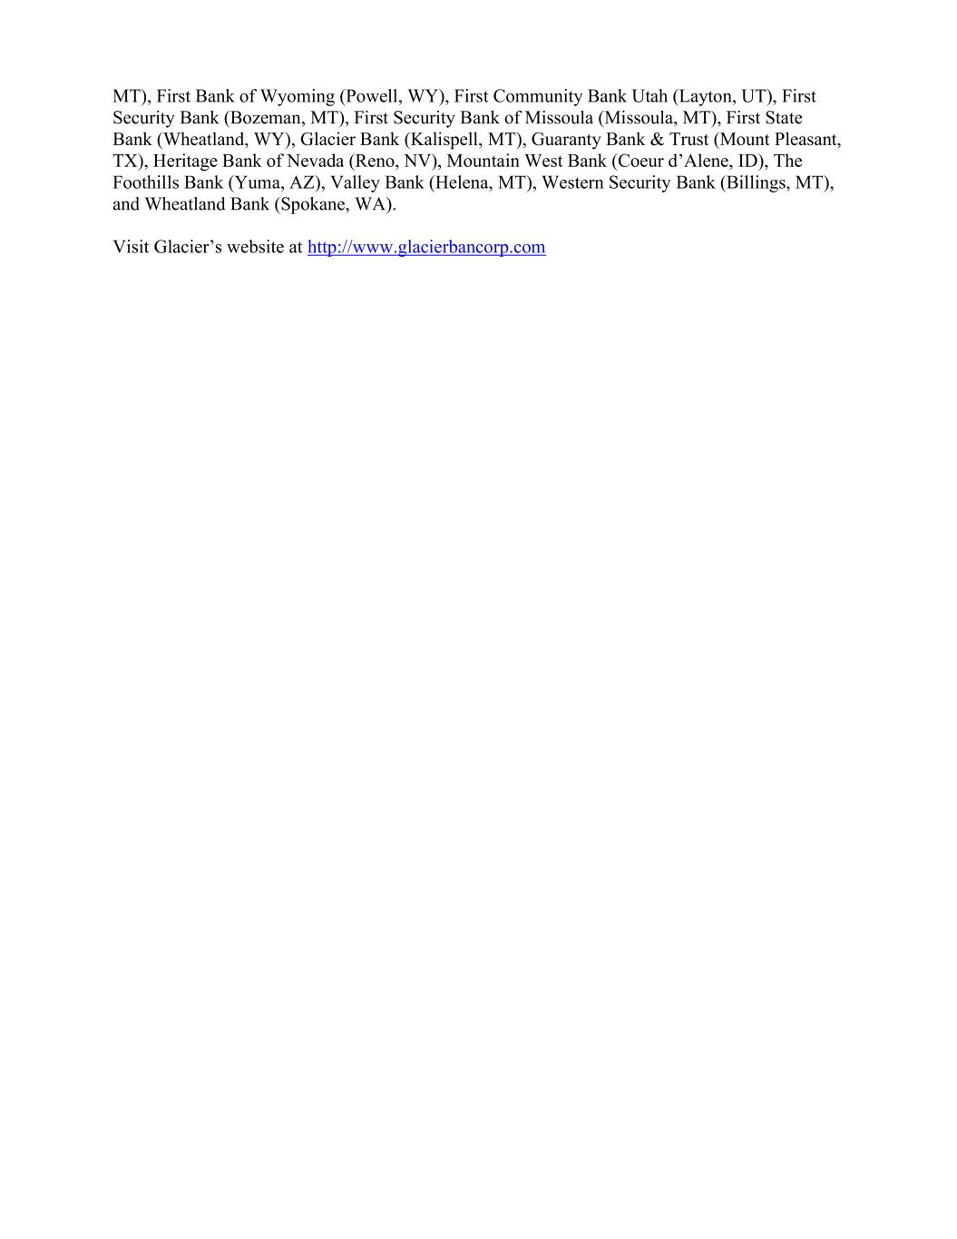
MT), First Bank of Wyoming (Powell, WY), First Community Bank Utah (Layton, UT), First Security Bank (Bozeman, MT), First Security Bank of Missoula (Missoula, MT), First State Bank (Wheatland, WY), Glacier Bank (Kalispell, MT), Guaranty Bank & Trust (Mount Pleasant, TX), Heritage Bank of Nevada (Reno, NV), Mountain West Bank (Coeur d’Alene, ID), The Foothills Bank (Yuma, AZ), Valley Bank (Helena, MT), Western Security Bank (Billings, MT), and Wheatland Bank (Spokane, WA). Visit Glacier’s website at http://www.glacierbancorp.com

